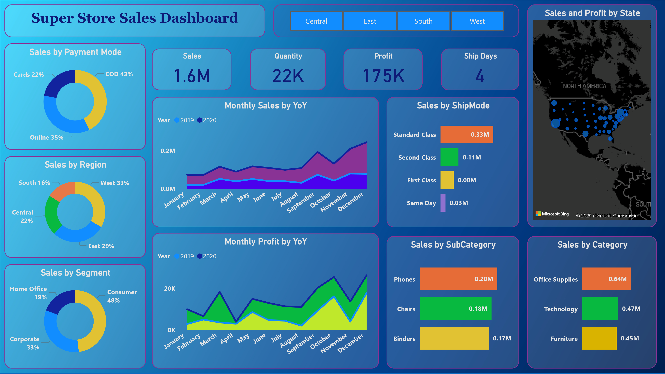

Power BI Desktop



Sales forecast 15 days

**0**

**K**

**5**

**K**

**10**

**K**

**Jan 2019**

**Apr 2019**

**Jul 2019**

**Oct 2019**

**Jan 2020**

**Apr 2020**

**Jul 2020**

**Oct 2020**

**Jan 2021**

Sales forecast 15 Days

**K**

**0**

**K**

**5**

**K**

**10**

**Dec 2020**

**Jan 2021**

K

3.0

10.6

K

0.2

K

0.6

K

8.1

K

9.7

K

0.2

K

Super Store Sales Forecast- 15 Days Forecast